Section C.3
1.3.1
The application is made for cell phone stores to order new stock from their suppliers.
The main functionality of the system is to obtain orders for new cell phones and put the orders into a data base for the where house operators to see and ship out the cell phones.
The user input consists of the model code the brand/make of the phone and the amount that they want to order.
1.3.2:
Test case | Input | Expected Result | Actual Result | Status
Tc01 | Input a name (erik) into the Mobile code field | Error message: enter valid code | Prints to the table without inter Ference | Fail
Tc02 | Press delete button | It removes the field that was added | It removes the field but fails to remove some aspects and displays wrong text . | fail
Tc03 | Pres find button when there is no data in the table | Finds nothing and displays Record not found | Record not found displayed and nothing found | pass
Tc04 | Input invalid number (number is to lag) | Prevents user to add number message appears saying number to large | Adds number to table | fail
TC05 | Entered name in Quantity field | Displays error message :add a valid quantity | Adds name instead of a number | Fail

TC01
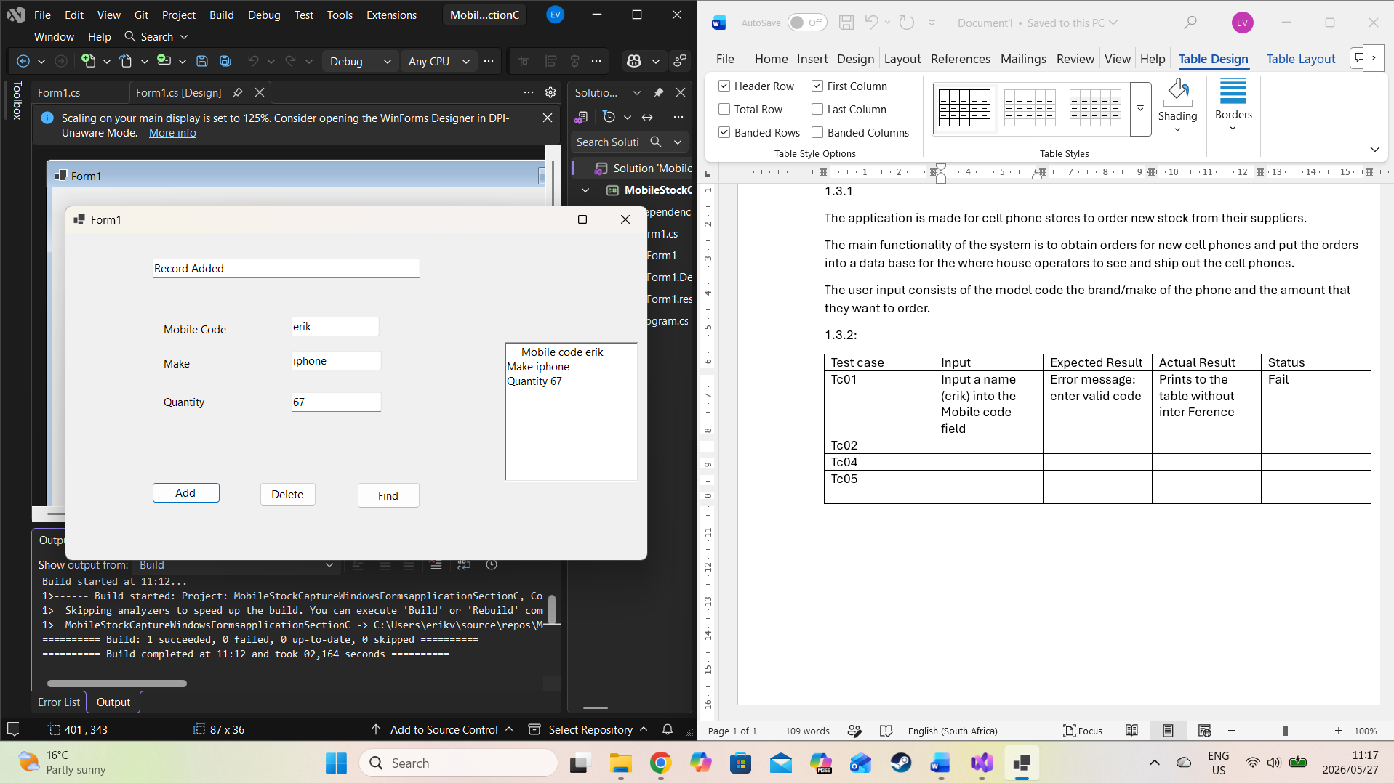

TC02
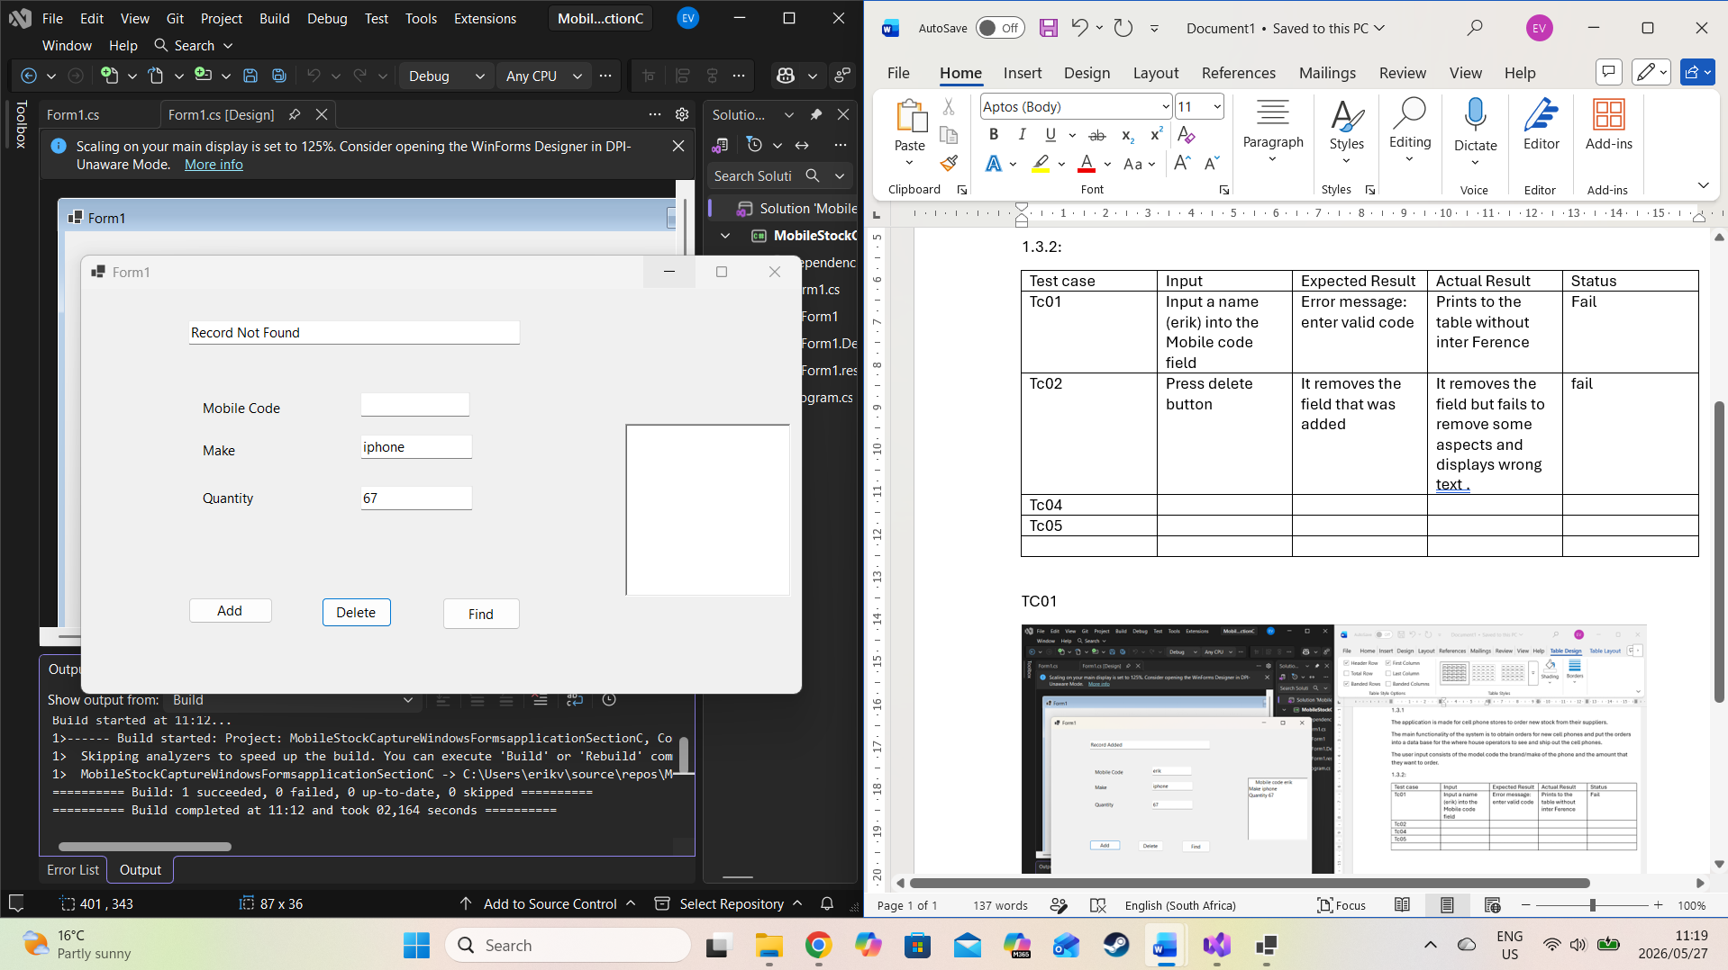

TC03
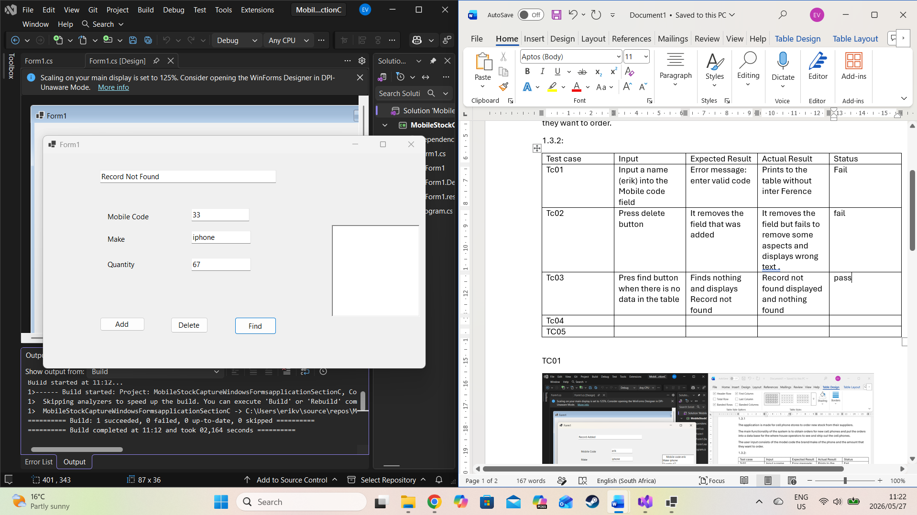

TC04
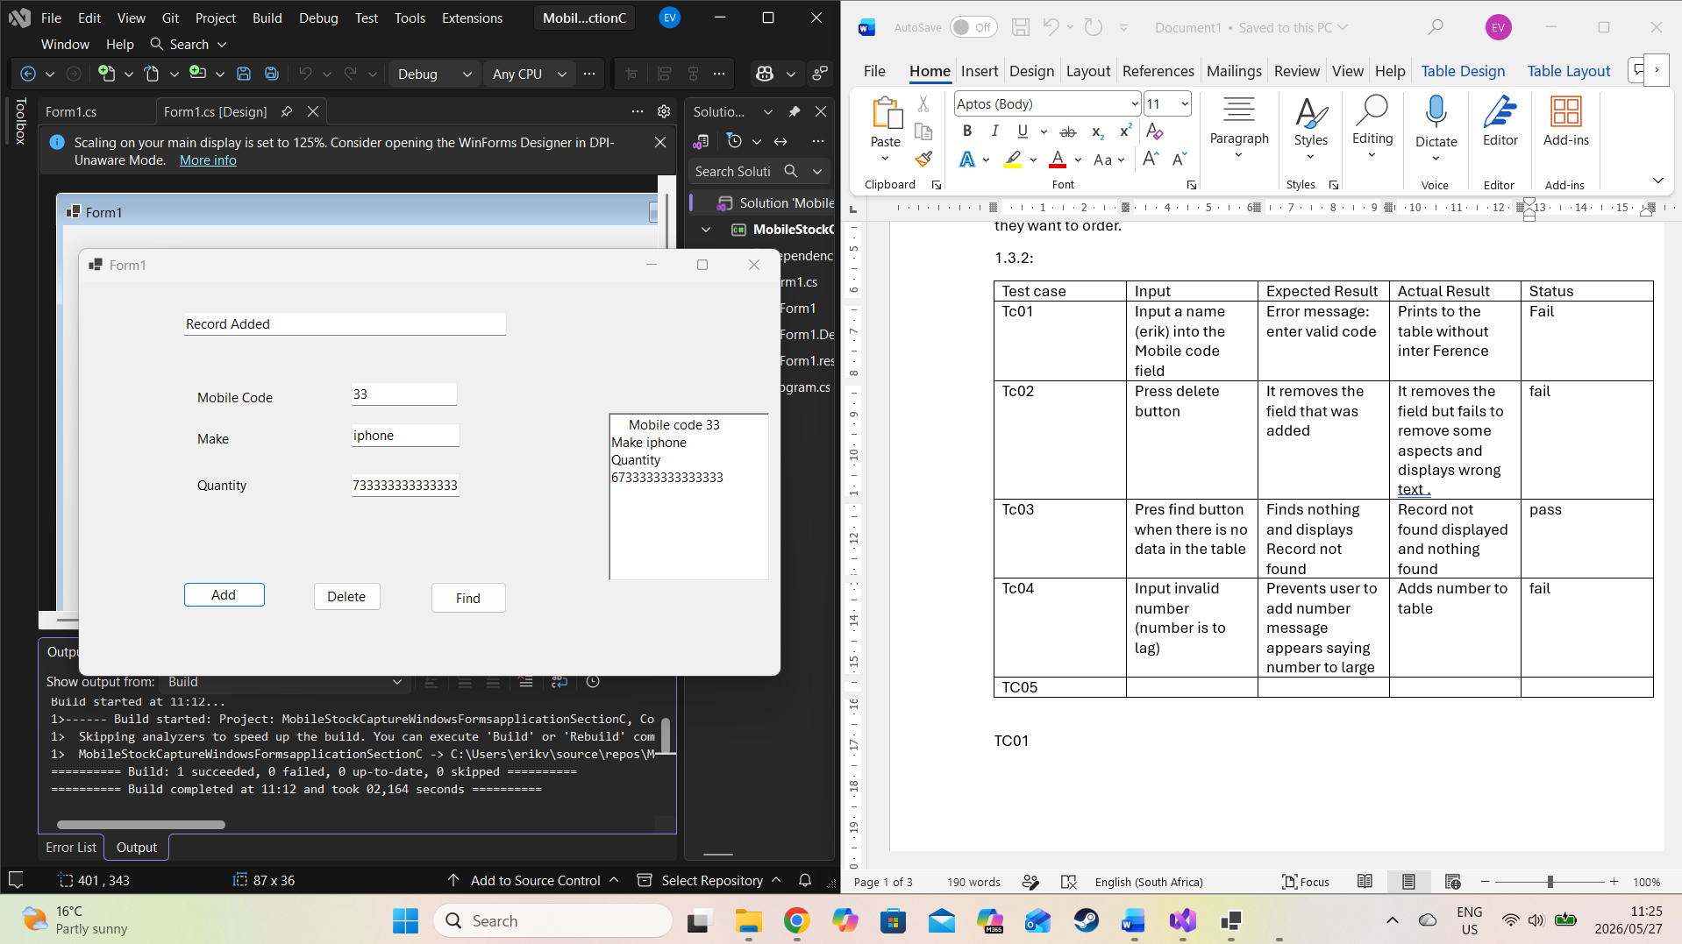

TC05
